Grade 2
Polybius Cipher

Description: | Students will:  Draw an illustration.  Draw another object that will increase or decrease in size as a cipher clue.  Use decimals to increase and decrease the size of a drawing.  Make a script that provides action for the clue.  Make a reset script and a button to fire the script.  Learn about the Polybius Cipher; use it to caption the project.  Apply information about array’s rows and columns to  encipher the caption.
Project View | 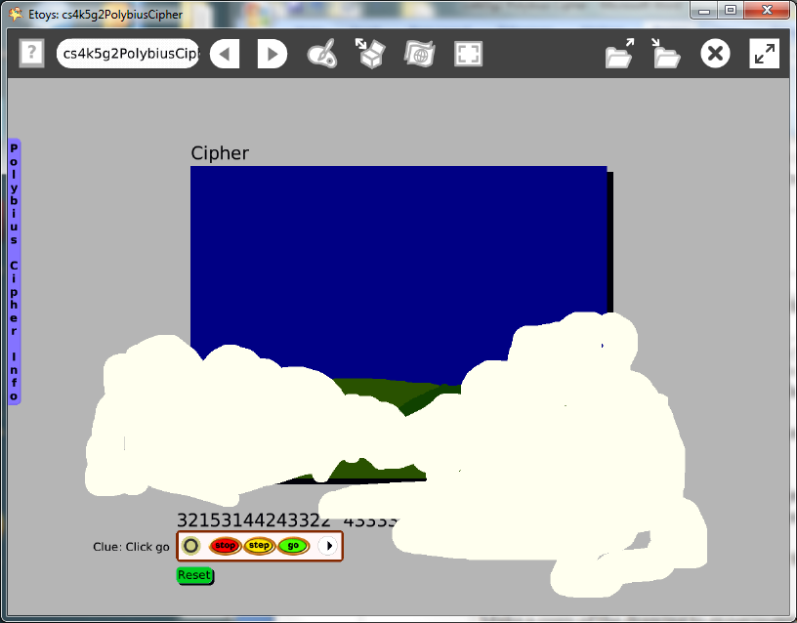
Subject: | Mathematics
Etoys Quick Guides | Click the question mark in Etoys to open the set of interactive tutorials for basic tools and techniques.
Vocabulary: | Array, rows, horizontal, columns, vertical, cipher, encipher
Lesson 1:  Paint Tools  Script Tiles: Forward and Turn  Script Tiles: Scale Factor | Discuss ideas about something that moves on a background. For example, a car on a road, a bird flying in the sky, sunrise, etc.  Draw a simple background illustration, more like a cartoon or comic book panel, and keep it.  Open a new paint palette and draw the object that will change. The change could be that it goes forward and or turns.  This example project uses the scale factor tile to represent melting snow.  Make a copy of the drawing to experiment with and change the copy’s size to the smallest and the largest it can be. Discuss making things bigger and smaller with the yellow resize handle.  Ask: what if we want to know exactly how much bigger or smaller we have made our drawing? Experiment with the scale factor tile in the Geometry category to change the size. Highlight the 1 and change it to 2, 3, etc. Discuss precision and control with the numbers. Give students time to experiment with their object and with their near neighbors’ drawings.  Keep the project, name it: namePolybius. E.g.: katePolybius
Lesson 2  Supplies: All Scripts  Menus: Button Fires a Script: | Open the Polybius project.  Open a Viewer for the drawing that will change sizes. Open the geometry category: scale factor.  Experiment with the small up/down arrows by the number to change the size in smaller increments. Give students time to explore the long enough to find the biggest and smallest changes possible. What are the limits?  Make a script using the scale factor tile. In the script, click on the small black arrow to open a menu, choose: increase by or decrease by and type in a number. Give them time to try .10, .50 and other decimal values that can be associated with money as the increase by or decrease by value in the script. Give students time to decide what decimal value makes their drawing do what they imagine it should do.  Use an All Scripts button from Supplies to start and stop this script.  Make a reset script that puts the drawing at a specific x and y location and specifies the starting size of the drawing. Make a button to fire this script.  Keep the project
Lesson 3:  Supplies: Text  Supplies: Add a New Flap  Supplies: Digital Images | Give students practice learning to use the cipher with paper and pencil. Discuss the convention that a letter’s row position is listed first and then the column location. Thus A=11, B12, F21 etc.  Open the cipher project.  Encipher the caption.  Type a caption for the illustration using Text from Supplies.  Use another Text from Supplies and type the enciphered message. Leave both so students can check each other’s spelling and ciphering accuracy. Discard the caption text or conceal it in a flap.  Students should decide how difficult they want their project to be and how much help they want to provide.  Discuss whether or not to include a key and where it should be. The key can be a digital image or it can be constructed with paint tools.  Publish the project: namePolybiusFinal.  Give students time to try their classmates’ Polybius ciphers
Standards: | Common Core Standards  Mathematics: 2.OA.4; 2.MD.8  Bloom’s Taxonomy/Cognitive Domain:  Knowledge: knows  Application: uses  NETS  1. a  3.
Resources: | Etoys Help Quick Guides: always available in Etoys. Open Etoys and click the question mark to open a set of interactive tutorials of basic tools and techniques.  www.etoysillinois.org projects, lesson plans, software download  www.mste.Illinois.org more math, science, and technology resources  www.corestandards.org Common Core Standards  www.squeakland.org software and Etoys projects  www.nctm.org Standards and Focal Points for each grade level
kh January 2011

